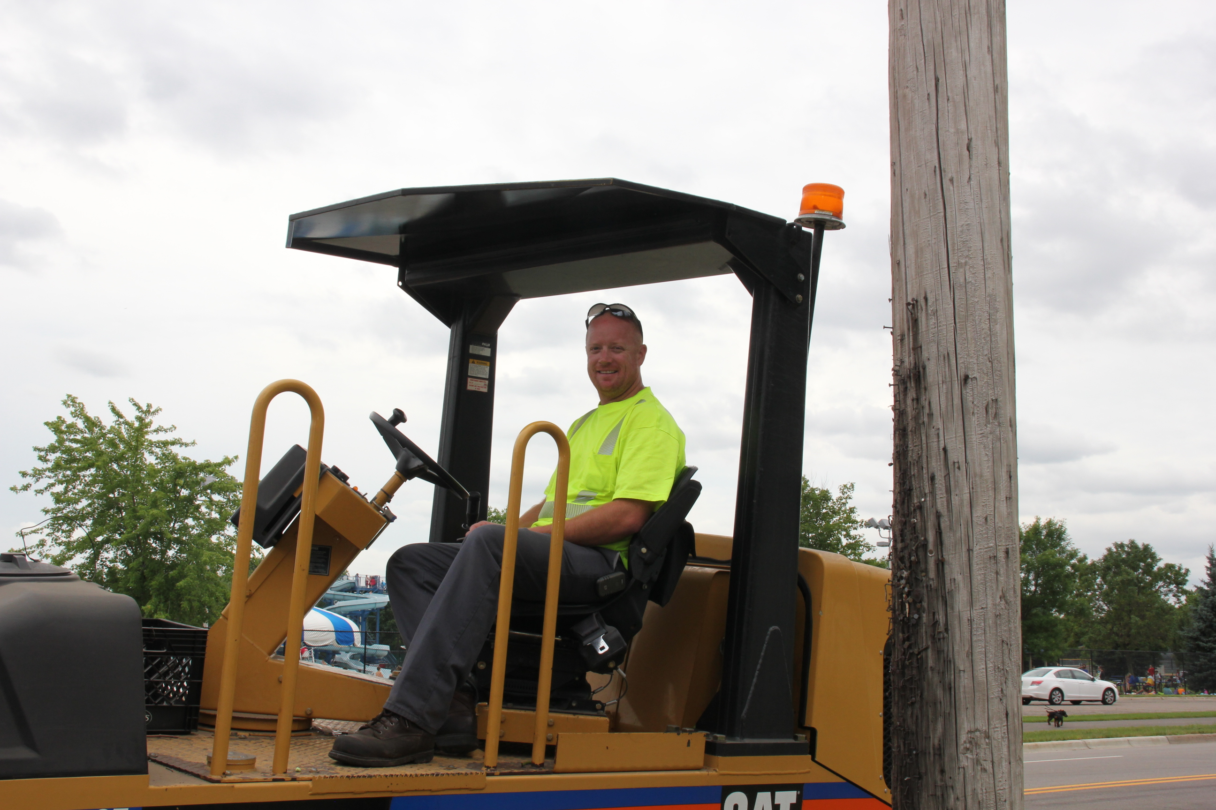

With tremendous sadness, we must report that a City of Bloomington Public Works employee has died as a result of injuries he sustained in a two-car crash on Thursday, January 28, at the 400 block of American Boulevard East. An SUV rear-ended a stationary City of Bloomington Public Works truck occupied by two City employees who were with a crew performing snow removal.
Equipment Operator Tyler Lenort, one of the occupants in the truck, died from his injuries. Equipment Operator Daryl Bittmann, who was also in the truck, remains in the hospital with serious injuries.
“It is with much sadness that I report the passing of Tyler Lenort. He was a dedicated City employee of 15 years who will be greatly missed,” City Manager Jamie Verbrugge said. “Our thoughts and condolences are with Tyler’s family, friends and coworkers during this very difficult time. We are also focused on Daryl’s recovery. He is a dedicated employee of more than 28 years."

Please visit Tyler’s CaringBridge site.

